TECHNICAL PROJECT REPORT

# Title of Invention / Project: COMMUNICATION SYSTEM FOR DIFFERNTLY ABLED PERSON

# Team Members / Inventors:

|  |  |  |  |  |  |
| --- | --- | --- | --- | --- | --- |
| **S. No.** | **Name** | **Department** | **Designation** | **Mobile** | **E-Mail** |
| 1. | ARINDAM | B.E-CSE(IOT) | TEAM LEADER | 9748763900 | Bufferedreader2@gmail.com |
| 2. | VIVEK JOSHI | B.E-CSE(IOT) | TEAM MEMBER | 8057758446 | vivekjoshi84392@gmail.com |
| 3. | KIRTI | B.E-CSE(IOT) | TEAM MEMBER | 9671494755 | kirtik98960@gmail.com |
| 5. | Khushal Thakur | ECE | Mentor | 9646030764 | khushal.thakur@cumail.in |
| 6. | Anshul Sharma | ECE | Mentor | 9478697475 | anshulsharma.ece@cumail.in |
| 7. | Kiran Jot Singh | ECE | Mentor | 9463909689 | kiranjotsingh.ece@cumal.in |
| 8. | Divneet Singh Kapoor | ECE | Mentor | 9878422653 | divneet.ece@cumail.in |

Section – 1 (IPR Related)

# Brief Abstract (500 words):

* **Problem your project is solving:**

Our project is solving the problem for differently abled person. In our project deaf person will be able communicate with other person in case if other person does not know the any sign language. It is helpful for the person who is deaf.

* **How are you solving that (solution)?:**

We are solving the problem by making voice to text controlled .In the project the person will speak in the mobile phone and that same text will be printed in mobile phone as well as in LCD also so that that deaf person be able to read that text will be able to understand what other person is trying to say that will be able to reply . It will help the that deaf person by making him/her independent and He/she does not need any other person to help in translating the message by the help of sign language.

* **Additional modifications that can cater to improved solution:**

Additional modification that we can add in this project/model is that converting it into a smart watch and which the deaf person can which will show time when not in use another modification we can add in this is that we can use 3d hologram in the watch besides this we can add a voice detector in the smart watch so that mobile phone is not used in this.

# **Existing state-of-the-art and Drawbacks in existing state-of-the-art:**

|  |  |  |
| --- | --- | --- |
| **S. No.** | **Existing state of art** | **Drawbacks in existing state of art** |
| 1 | US4268721A  A portable telephone communications device for the hearing impaired can be carried in the pocket of the user and attaches directly to the telephone handset without intrusion. It includes a keyboard and a readout which enables the user to transmit data by means of the keyboard and receive data which is presented on either an electronic display or a printer or both. | Drawback in this existing state of art is that it uses keyboard for printing of text in that portable telephone and present on either an electronic display or printer . |
| 2 | KR101017421B1  The present invention relates to a communication system for the hearing impaired, when the deaf connecting a call and the remote interpretation centre to the sign language video call an interpreter resides possible, by connecting to the interpretation centre to remotely interpreter and sign language video call It characterized by consisting of a mobile communication device capable. Using the communication system according to the invention when the hearing impaired may advantageously be a smooth and accurate pseudo or near and the far geoncheongin communication by using a mobile communication device capable of interpretation centre and remote access. | Drawback in this existing state of art that it uses very long process to transmit message to the deaf person and every time the connectivity of internet is not possible and the quality of video call may be poor and deaf person may not be able to understand the message. |

# Novel/Additional modifications that you can propose to improve upon drawbacks

* Modification that we can propose that our project directly converts of person voice into text via an app through google voice recognition which has already installed languages instead of using keyboard which reduces person efforts.
* Modification that we can propose that our project is fast as compared to remote interpretation and misinterpretation of person message become less.

# Advantages

* It reduces persons effort .It is easy to handle .
* It is better than remote interpretation that message can transferred fast and does not need third person to include and does not include video calling.

# Block Diagram:

**ANDR-OID DEVICE**

SSS

**BLUET-OOTH MOD- ULE**

**LCD**

(DISPLAY THE TEXT)

**MICRO CONTR-OLLER**

SENDS TEXT SENDS T SENDS TEXT

VIA BLUETOOTH

SIGNAL

(CONVERTS THE SPEECH (RECIVES SIGNAL

INTO TEXT) SENDS TO ARDIUNO)

(SENDS THE TEXT SIGNAL

TO LCD)

Section – 2 (Real Project)

# Materials:

1.Ardunio Uno

2.20*4 LCD display

3.Bluetooth module HC-05

4.Jumping wires

5.Potentiometer

6.Breadbored

# Circuit Diagram:

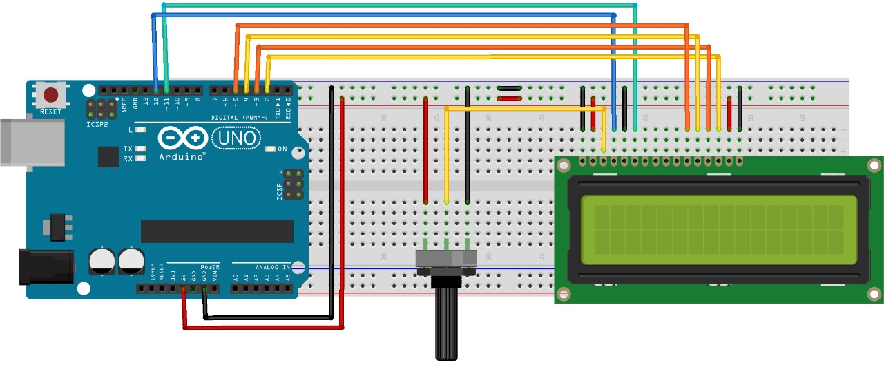

# Steps of Circuit Completion:

STEP1:LCD CONNECTION:

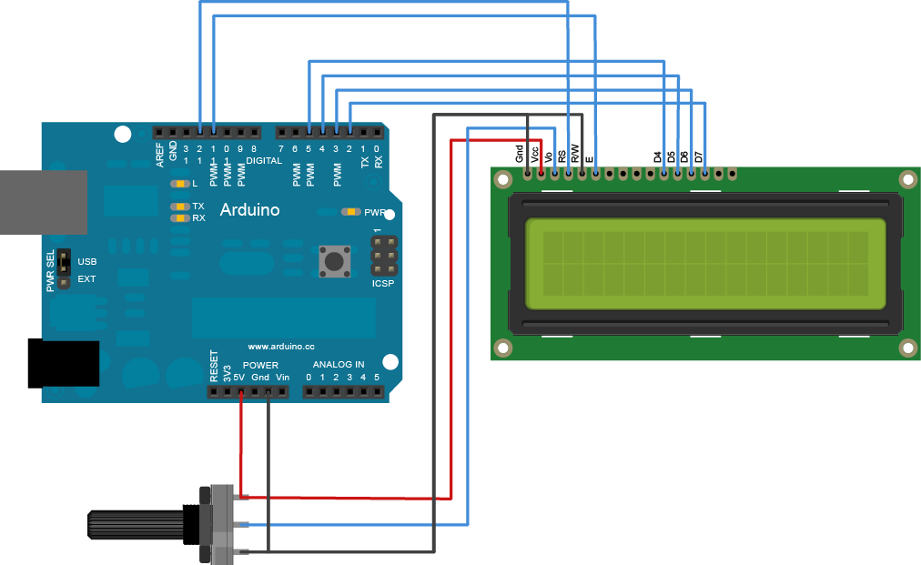

STEP2:BLUETOOTH CONNECTION:

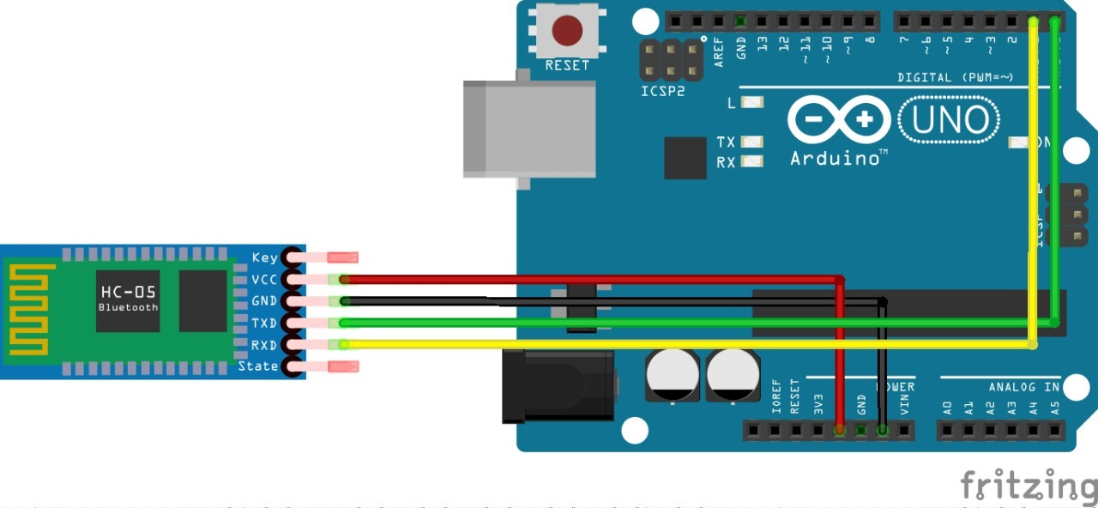

STEP3: APP DEVLOPMENT:

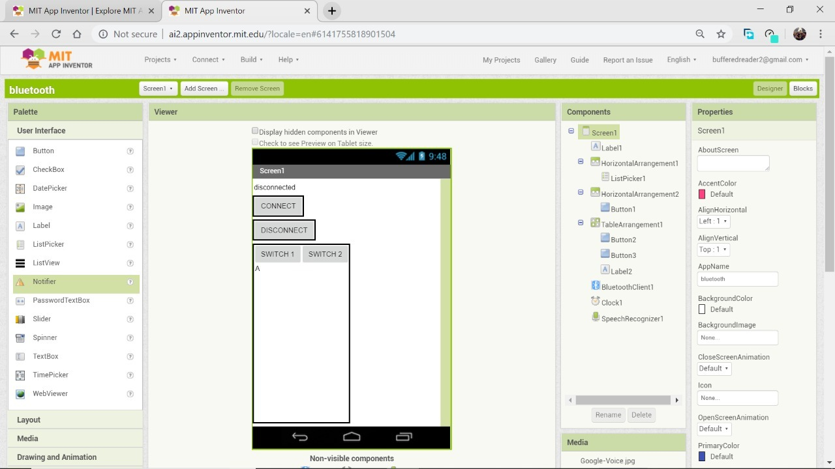

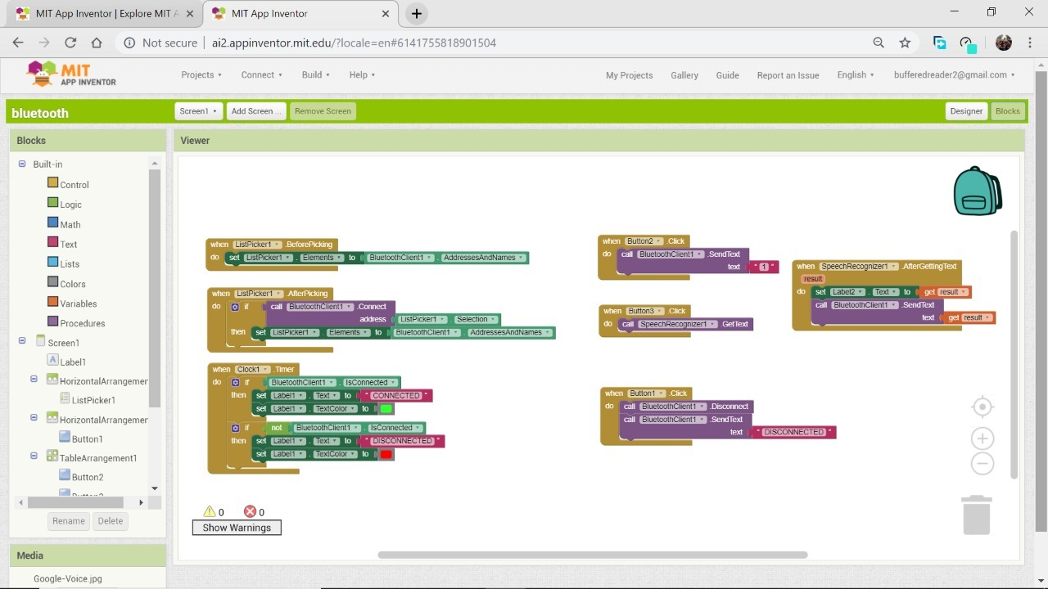

STEP 4: ROUGH MODEL:

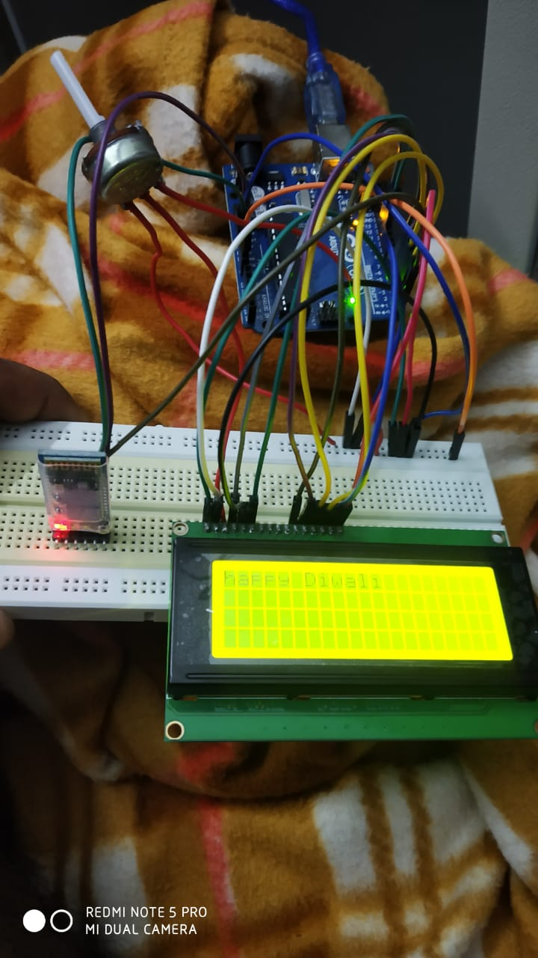

STEP5: FINAL PROJECT WITH APP:

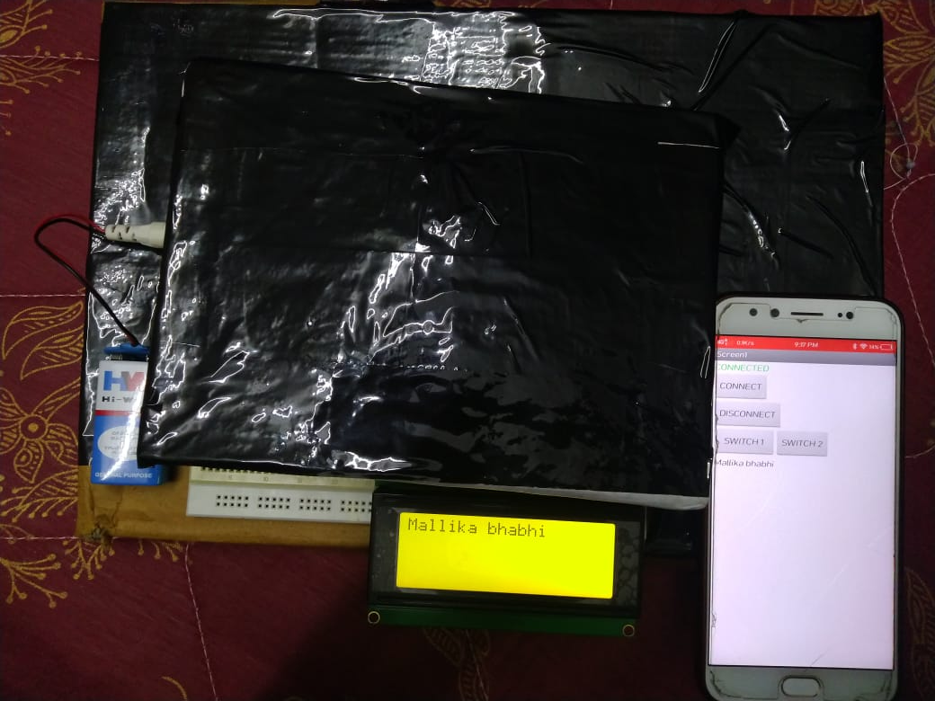

# Program Code :

https://github.com/arindamsamanta5507/Projects/blob/master/project.ino